**Understanding Language with Computers**

student: Clara Osterburg Correa Immatr: 6050790

student: Saskia Juergens Immatr: 6143565

student: Subrina Jahan Immatr: 6100956

name**:** “RobotTalkZone”

Domain: conversation logs / a conversation chatbot

**Task:** Annotate a part of you corpus

Part of Data.jison

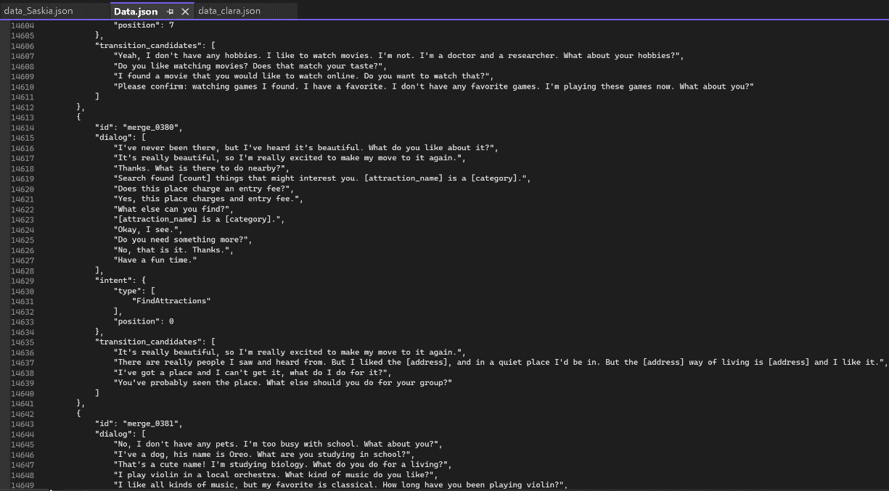

End part of data_clara.json:

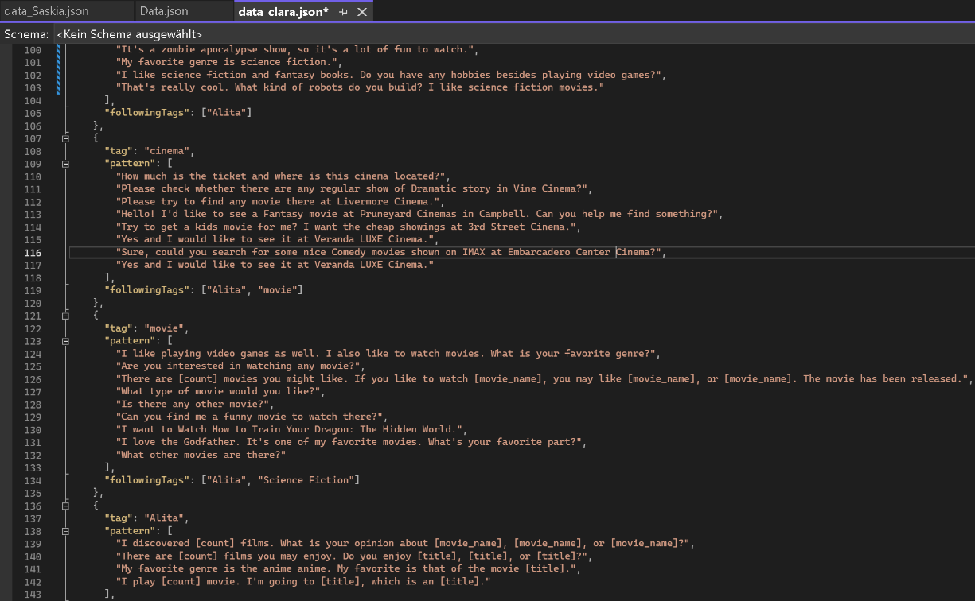

End part of data_Saskia.json:

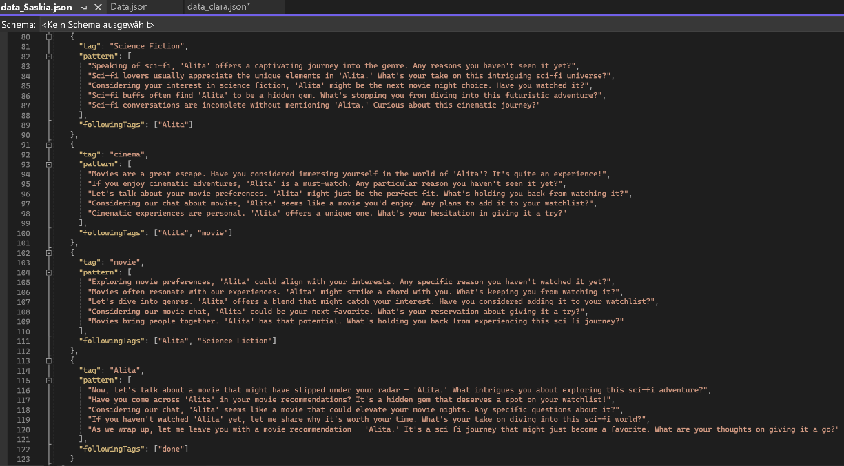

Calculating the Cohen's Kappa involves having a confusion matrix, observed agreement probability, and expected agreement probability.

In the context of a chatbot, determining these values is challenging because there aren’t clear "ground truth" or gold standard for comparison.

However, instead of a confusion matrix, we could manually evaluate a sample of interactions and categorize them into different classes based on the appropriateness or correctness of the chatbot's response. But therefore the chatbot needs to be operational and capable of generating responses which is not the case yet.

It can be noted that in the 'data_clara' approach, the chatbot comes across as more human-like, often reusing responses from users. On the other hand, the 'data_Saskia' approach gives a more sales-oriented impression, resembling a seller recommending the movie 'Alita' to the user.